

Viernes, 12 de junio 2020

Lee, ordena y trascribe las frases.

1. Cecilia come queso.

2. El asno usa jáquima.

3. La máquina es de metal.

4. Alicia prepara panqueques.

5. Yo juego con mi raqueta.













Viernes, 12 de junio 2020

Observa la ilustración y crea tus propias oraciones.

No olvides usar mayúscula y punto final.

1. ____________________________________________________

______________________________________________________

______________________________________________________

2. ____________________________________________________

______________________________________________________

______________________________________________________

3. ____________________________________________________

______________________________________________________

______________________________________________________

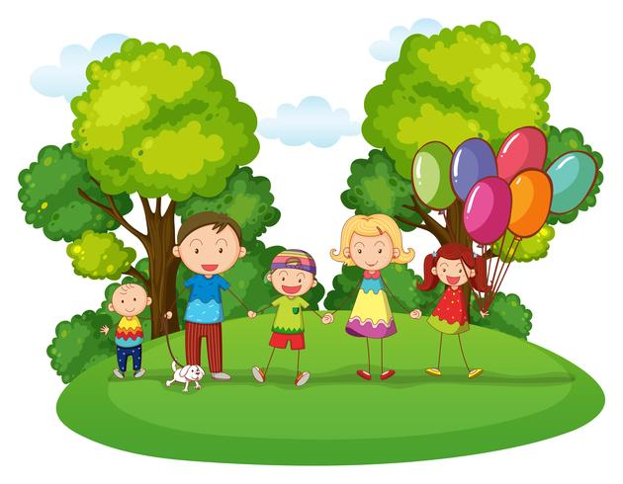



Viernes, 12 de junio 2020

Continúa…

1. ____________________________________________________

______________________________________________________

2. ____________________________________________________

______________________________________________________

3. ____________________________________________________

______________________________________________________

4. ____________________________________________________

______________________________________________________

5. ____________________________________________________

______________________________________________________

