 **RAÌZ ENESIMA - 3°MEDIO**

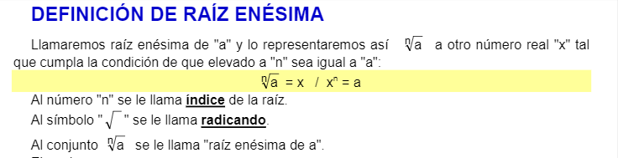

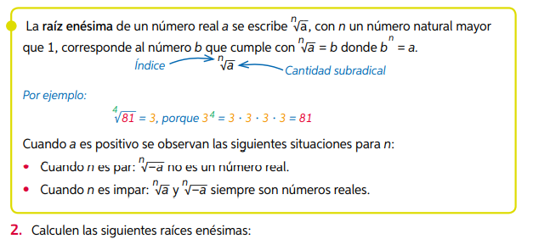

|  |  |  |
| --- | --- | --- |
|  |  |  |
|  |  |  |

|  |
| --- |
|  |
| * ***PROPIEDAD FUNDAMENTAL DE LAS RAÌCES:*** |

